Participant 1: She is a senior college student who has very little experience on using digital drawing tools.

Transcript:

Q: Have you ever received any professional training in drawing/painting? Or what art materials do you have experience with? (Pencil, marker, etc.)?

A: I have used some. Photoshop, the drawing tools from Microsoft etc. But I’ve only used them for a very short time. So, yeah…

Q: How did you decide to use these colors and shapes?

A: Since it is a police car, it for sure have the blue and red light. And it also has that little window with wires. The shape is in black line since it is the default color. The black segment seems fine to me.

Q: How are you feeling as you are drawing?

A: I think it’s fine.

Q: At what point did you feel like your drawing was good enough to call it a complete piece? How did you decide to continue drawing after that point?

A: While I just stopped when I complete the color. But I felt like I need to add a flashlight and an aerial.

Q: How is this feeling compared to drawing on real paper?

A: I do not draw on real paper quite so often. But I would say that the mouse is very hard to control to draw. The color is quite easy on digital tools though.

Screenshot:

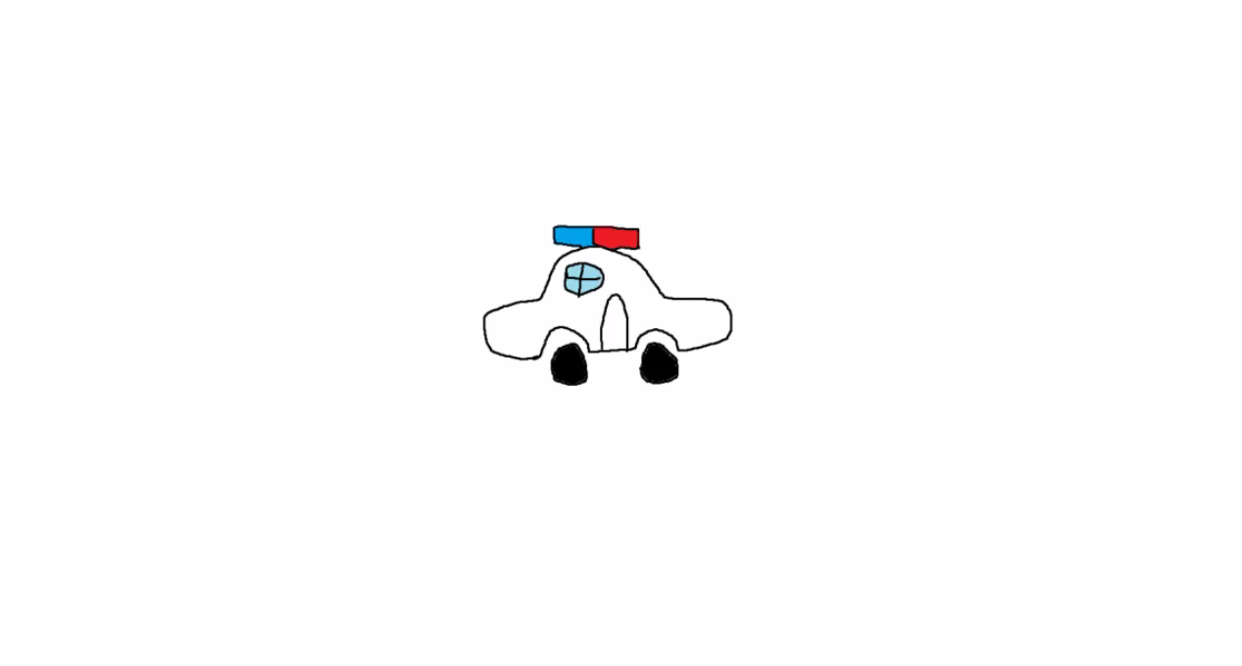

Finding 1: **Participants tend to have more options/features, but it will make them feel nervous.** Participants love features that will make drawing easier such as shaping and coloring tools. Especially tools with algorithm that can adjust the shape and color to make the whole drawing looks better. However, if participants were given a large number of tools, it will take much longer for them to finish the painting. And it will cause nervous as they constantly asked me how to use those tools.